SBA-III ASSESSMENT

**1.Create Database project_movie_data and deploy table data according to ER diagram.**

CREATE DATABASE project_movie_data;

use project_movie_data;

**2.Create 9 tables which are presented in ER model and load the data with their foreign key and primary key values.**

CREATE TABLE IF NOT EXISTS actor (

act_id int(4) ,

act_fname char(20),

act_lname char(20),

act_gender char(1) ,

PRIMARY KEY (act_id)

);

INSERT INTO actor (act_id, act_fname, act_lname, act_gender) VALUES

(101, 'James', 'Stewart', 'M'),

(102, 'Deborah', 'Kerr', 'F'),

(103, 'Peter', 'OToole', 'M'),

(104, 'Robert', 'De Niro', 'M'),

(105, 'F. Murray','Abraham ', 'M'),

(106, 'Harrison','Ford', 'M'),

(107, 'Nicole', 'Kidman ', 'F'),

(108, 'Stephen', 'Baldwin ', 'M'),

(109, 'Jack', 'Nicholson', 'M'),

(110, 'Mark', 'Wahlberg ', 'M'),

(111, 'Woody','Allen', 'M'),

(112, 'Claire','Danes', 'F'),

(113, 'Tim', 'Robbins', 'M'),

(114, 'Kevin','Spacey', 'M'),

(115, 'Kate','Winslet', 'F'),

(116, 'Robin', 'Williams', 'M'),

(117, 'Jon', 'Voight', 'M'),

(118, 'Ewan', 'McGregor', 'M'),

(119, 'Christian','Bale','M'),

(120, ' Maggie', 'Gyllenhaal','F'),

(121, 'Dev', 'Patel', 'M'),

(122, 'Sigourney', 'Weaver', 'F'),

(123, 'David', 'Aston', 'M'),

(124, 'Ali', 'Astin', 'F');

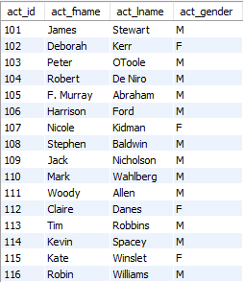

CREATE TABLE IF NOT EXISTS director (

dir_id int(4) ,

dir_fname char(20),

dir_lname char(20) ,

PRIMARY KEY (dir_id)

);

--

-- Dumping data for table `director`

--

INSERT INTO director (dir_id, dir_fname, dir_lname) VALUES

(201, 'Alfred', 'Hitchcock'),

(202, 'Jack', 'Clayton'),

(203, 'David', 'Lean'),

(204, 'Michael', 'Cimino'),

(205,'Milos', 'Forman'),

(206,'Ridley', 'Scott'),

(207,'Stanley','Kubrick'),

(208,'Bryan', 'Singer'),

(209,'Roman', 'Polanski'),

(210,'Paul', 'Thomas An'),

(211,'Woody', 'Allen'),

(212,'Hayao', 'Miyazaki'),

(213,'Frank','Darabont'),

(214,'Sam','Mendes'),

(215,'James','Cameron'),

(216, 'Gus', ' Van Sant'),

(217, 'John', ' Boorman'),

(218, 'Danny', ' Boyle'),

(219, 'Christoph', 'Nolan'),

(220, 'Richard', 'Kelly'),

(221, 'Kevin', 'Spacey'),

(222, 'Andrei', 'Tarkovsky'),

(223, 'Peter', 'Jackson');

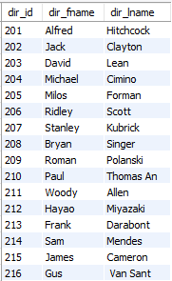

CREATE TABLE IF NOT EXISTS genres (

gen_id int(5),

gen_title char(20) ,

PRIMARY KEY (gen_id)

);

INSERT INTO genres (gen_id, gen_title) VALUES

(1001, 'Action'),

(1002, 'Adventure'),

(1003, 'Animation'),

(1004, 'Biography'),

(1005, 'Comedy'),

(1006, 'Crime'),

(1007, 'Drama'),

(1008, 'Horror'),

(1009, 'Music'),

(1010, 'Mystery'),

(1011, 'Romance'),

(1012, 'Thriller'),

(1013, 'War');

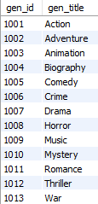

CREATE TABLE IF NOT EXISTS movie (

mov_id int(5) ,

mov_title char(50) ,

mov_year int(4),

mov_time int(5),

mov_lang char(10) ,

mov_dt_rel date,

mov_rel_country char(5) ,

PRIMARY KEY (mov_id)

);

INSERT INTO movie (mov_id, mov_title, mov_year, mov_time, mov_lang, mov_dt_rel, mov_rel_country) VALUES

(901, 'Vertigo', 1958, 128, ' English ', '1958-08-24', ' UK'),

(902, ' The Innocents ', 1961, 100, ' English ', '1962-02-19', ' SW'),

(903, ' Lawrence of Arabia ', 1962, 216, ' English ', '1962-12-11', ' UK'),

(904, ' The Deer Hunter ', 1978, 183, ' English ', '1979-03-08', ' UK'),

(905, ' Amadeus ', 1984, 160, ' English ', '1985-01-07', ' UK'),

(906, ' Blade Runner ', 1982, 117, ' English ', '1982-09-09', ' UK'),

(907, 'Eyes Wide Shut', 1999, 159, 'English', '0000-00-00', ' UK'),

(908, ' The Usual Suspects ', 1995, 106, ' English ', '1995-08-25', ' UK'),

(909, ' Chinatown ', 1974, 130, ' English ', '1974-08-09', ' UK'),

(910, ' Boogie Nights ', 1997, 155, ' English ', '1998-02-16', ' UK'),

(911, ' Annie Hall ', 1977, 93, ' English ', '1977-04-20', ' USA'),

(912, ' Princess Mononoke ', 1997, 134, ' Japanese ', '2001-10-19', ' UK'),

(913, ' The Shawshank Redem', 1994, 142, ' English ', '1995-02-17', ' UK'),

(914, ' American Beauty ', 1999, 122, ' English ', '0000-00-00', ' UK'),

(915, ' Titanic ', 1997, 194, ' English ', '1998-01-23', ' UK'),

(916, ' Good Will Hunting ', 1997, 126, ' English ', '1998-06-03', ' UK'),

(917, 'Deliverance', 1972, 109, ' English ', '1982-10-05', ' UK'),

(918, ' Trainspotting ', 1996, 94, ' English ', '1996-02-23', ' UK'),

(919, ' The Prestige ', 2006, 130, ' English ', '2006-11-10', ' UK'),

(920, ' Donnie Darko ', 2001, 113, ' English ', '0000-00-00', ' UK'),

(921, ' Slumdog Millionaire', 2008, 120, ' English ', '2009-01-09', ' UK'),

(922, ' Aliens ', 1986, 137, ' English ', '1986-08-29', ' UK'),

(923, ' Beyond the Sea ', 2004, 118, ' English ', '2004-11-26', ' UK'),

(924, ' Avatar ', 2009, 162, ' English ', '2009-12-17', ' UK'),

(925, ' Braveheart ', 1995, 178, ' English ', '1995-09-08', ' UK'),

(926, ' Seven Samurai ', 1954, 207, ' Japanese ', '1954-04-26', ' JP'),

(927, ' Spirited Away ', 2001, 125, ' Japanese ', '2003-09-12', ' UK'),

(928, ' Back to the Future ', 1985, 116, ' English ', '1985-12-04', ' UK');

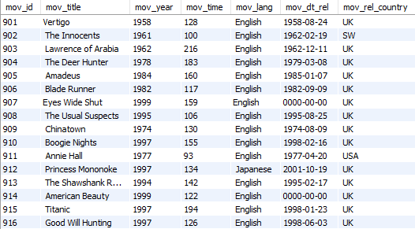

CREATE TABLE IF NOT EXISTS movie_cast (

act_id int(4),

mov_id int(4),

role char(30),

foreign key(act_id) references actor(act_id),

foreign key(mov_id) references movie(mov_id)

);

INSERT INTO movie_cast (act_id, mov_id, role) VALUES

(101, 901, 'John Scottie Fergus'),

(102, 902, 'Miss Giddens'),

(103, 903, 'T.E. Lawrence'),

(104, 904, 'Michael'),

(105, 905, 'Antonio Salieri'),

(106, 906, 'Rick Deckard'),

(107, 907, 'Alice Harford'),

(108, 908, 'McManus'),

(110, 910, 'Eddie Adams'),

(111, 911, 'Alvy Singer'),

(112, 912, 'San'),

(113, 913, 'Andy Dufresne'),

(114, 914, 'Lester Burnham'),

(115, 915, 'Rose DeWitt Bukater'),

(116, 916, 'Sean Maguire'),

(117, 917, 'Ed'),

(118, 918, 'Renton'),

(120, 920, 'Elizabeth Darko'),

(121, 921, 'Older Jamal'),

(122, 922, 'Ripley'),

(114, 923, 'Bobby Darin'),

(109, 909, 'J.J. Gittes'),

(119, 919, 'Alfred Borden');

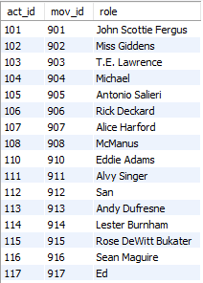

CREATE TABLE IF NOT EXISTS movie_direction (

dir_id int(4) ,

mov_id int(4),

foreign key(dir_id) references director(dir_id),

foreign key(mov_id) references movie(mov_id)

);

INSERT INTO movie_direction (dir_id, mov_id) VALUES

(201, 901),

(202, 902),

(203, 903),

(204, 904),

(205, 905),

(206, 906),

(207, 907),

(208, 908),

(209, 909),

(210, 910),

(211, 911),

(212, 912),

(213, 913),

(214, 914),

(215, 915),

(216, 916),

(217, 917),

(218, 918),

(219, 919),

(220, 920),

(218, 921),

(215, 922),

(221, 923);

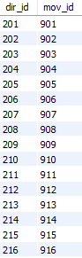

CREATE TABLE IF NOT EXISTS movie_genres (

mov_id int(5) ,

gen_id int(5),

foreign key(gen_id) references genres(gen_id),

foreign key(mov_id) references movie(mov_id)

);

INSERT INTO movie_genres (mov_id, gen_id) VALUES

(922, 1001),

(917, 1002),

(903, 1002),

(912, 1003),

(911, 1005),

(908, 1006),

(913, 1006),

(926, 1007),

(928, 1007),

(918, 1007),

(921, 1007),

(902, 1008),

(923, 1009),

(907, 1010),

(927, 1010),

(901, 1010),

(914, 1010),

(906, 1012),

(904, 1013);

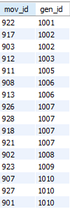

CREATE TABLE IF NOT EXISTS reviewer (

rev_id int(4) ,

rev_name char(30) ,

PRIMARY KEY (rev_id)

);

INSERT INTO reviewer ( rev_id, rev_name) VALUES

(9001,"Righty Sock"),

(9002,"Jack Malvern"),

(9003,"Flagrant Baronessa"),

(9004,"Alec Shaw"),

(9005,NULL),

(9006,"Victor Woeltjen"),

(9007,"Simon Wright"),

(9008,"Neal Wruck"),

(9009," Paul Monks"),

(9010,"Mike Salvati"),

(9011 ,NULL),

(9012,"Wesley S. Walker"),

(9013,"Sasha Goldshtein"),

(9014,"Josh Cates"),

(9015,"Krug Stillo"),

(9016,"Scott LeBrun"),

(9017 ,"Hannah Steele"),

(9018,"Vincent Cadena"),

(9019 , "Brandt Sponseller"),

(9020 ," Richard Adams");

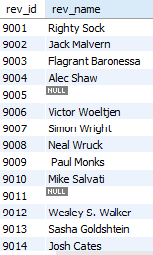

CREATE TABLE IF NOT EXISTS rating (

mov_id int(5),

rev_id int(5) ,

rev_stars float(4) ,

num_o_ratings int(10) ,

foreign key(mov_id) references movie(mov_id),

foreign key(rev_id) references reviewer(rev_id)

);

INSERT INTO rating (mov_id, rev_id, rev_stars, num_o_ratings) VALUES

(901, 9001, 8.4,263575),

(902, 9002, 7.9,20207),

(903, 9003, 8.3,202778),

(906, 9005, 8.2,484746),

(924, 9006, 7.3,NULL),

(908, 9007, 8.6,779489),

(909, 9008, NULL,227235),

(910, 9009, 3,195961),

(911, 9010, 8.1,203875),

(912, 9011, 8.4,NULL),

(914, 9013, 7,862618),

(915,9001,7.7,830095),

(916, 9014, 4,642132),

(925, 9015, 7.7,81328),

(918, 9016, NULL,580301),

(920, 9017, 8.1,609451),

(921, 9018, 8,667758),

(922, 9019, 6.4,511613),

(923, 9020, 6.7,13091);

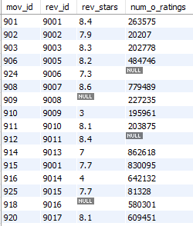

**3.Write a query in SQL to list the Horror movies?**

select mov_title from movie where mov_id in (select mov_id from movie_genres where gen_id in(select gen_id from genres where gen_title="Horror"));

HORROR QN

**4.Write a query in SQL to find the name of all reviewers who have rated 8 or more stars?**

SELECT reviewer.rev_name

FROM reviewer, rating

WHERE rating.rev_id = reviewer.rev_id

AND rating.rev_stars>=8

AND reviewer.rev_name IS NOT NULL;

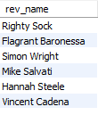

**5.Write a query in SQL to list all the information of the actors who played a role in the movie ‘Deliverance’?**

SELECT *

FROM actor

WHERE act_id IN(

SELECT act_id

FROM movie_cast

WHERE mov_id IN (

SELECT mov_id

FROM movie

WHERE mov_title="Deliverance"

));

DELEIVERANCE

**6.Write a query in SQL to find the name of the director (first and last names) who directed a movie that casted a role for ‘Eyes Wide Shut’. (using subquery)?**

select d.dir_fname , d.dir_lname

from director d , movie_direction md

where d.dir_id = md.dir_id

and md.mov_id in (select mov_id from movie where mov_title = 'Eyes Wide Shut');

**EYESWIDESHUT**

1. **Write a query in SQL to find the movie title, year, date of release, director and actor for those movies which reviewer is ‘Neal Wruck’?**

SELECT mov_title, mov_year, mov_dt_rel, dir_fname, dir_lname,

act_fname, act_lname

FROM movie a, movie_direction b, director c,

rating d, reviewer e, actor f, movie_cast g

WHERE a.mov_id=b.mov_id

AND b.dir_id=c.dir_id

AND a.mov_id=d.mov_id

AND d.rev_id=e.rev_id

AND a.mov_id=g.mov_id

AND g.act_id=f.act_id

AND e.rev_name ="Neal Wruck";

NEALWRECTQN